| **Overview** | We are analyzing economic, environmental, technological infrastructure, poverty, health, and financial data from two datasets which were downloaded to csv files. We would like to analyze different world indicator trends and perform a statistical analysis on them. |
| --- | --- |
| **Viz Ideas** | * [Time Series and Map Graph Example](https://ourworldindata.org/covid-mobility-trends) * [World Bank Poverty Data on Map](https://ourworldindata.org/explorers/poverty-explorer?time=2019&facet=none&country=BGD~BOL~KEN~MOZ~NGA~ZMB&Indicator=Number+in+poverty&Poverty+line=%242.15+per+day%3A+International+Poverty+Line&Household+survey+data+type=Income+surveys+only&Show+breaks+between+less+comparable+surveys=false) * [CO2 and Greenhouse Gas Chart](https://ourworldindata.org/explorers/co2?tab=map&facet=none&country=CHN~USA~IND~GBR~OWID_WRL&Gas+or+Warming=CO%E2%82%82&Accounting=Territorial&Fuel+or+Land+Use+Change=All+fossil+emissions&Count=Per+capita) |
| **Data Sources** | * World Bank World Development Indicators (2012-2022) <https://databank.worldbank.org/source/world-development-indicators> * Global Country Information Dataset (2023)   <https://www.kaggle.com/datasets/nelgiriyewithana/countries-of-the-world-2023/> |

**Examples of the raw Data:**

World Bank World Development Indicators (2012-2022)

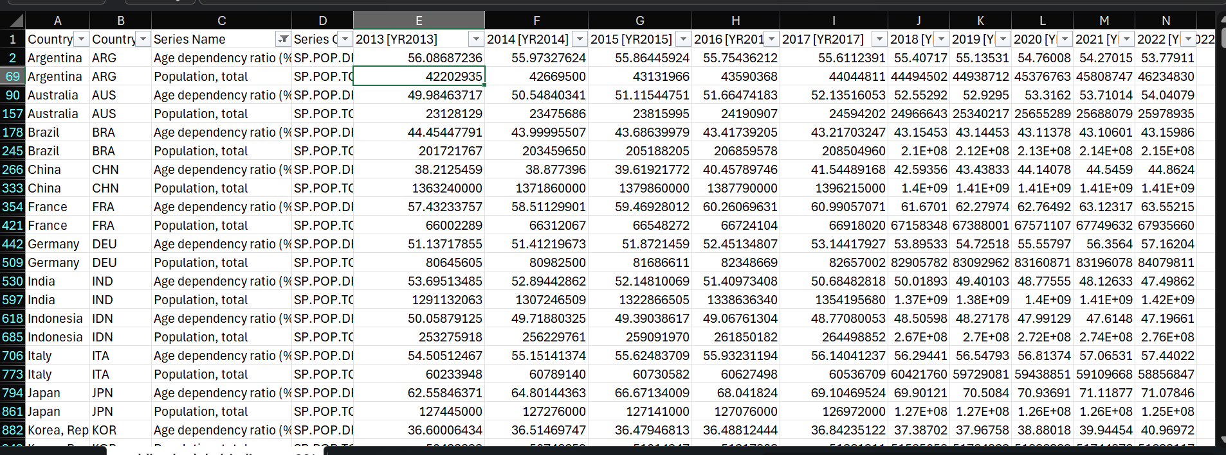

Global Country Information Dataset (2023)

